Lab 10

Objectives

To learn about use of different controls like buttons, text boxes, combo box and timer controls in C# applications and how to apply graphics and Mouse events.

ComboBox is a combination TextBox with a drop-down. Its drop-down list presents preset choices. The user can type anything into the ComboBox. Alternatively, he or she can select something from the list.
.
Example:
Create a simple C# that will place one combo box filled with the names of different shapes by using item property of combo box and application should be able to draw the selected shape of combo box control by creating graphic ,pen and solid brush objects.

namespace ListboxnCombo
{
public partial class Form1 : Form
{
public Form1()
{
InitializeComponent();
}

private void comboBox1_SelectedIndexChanged(object sender, EventArgs e)
{
Graphics g = base.CreateGraphics();
Pen p = new Pen(Color.Blue);
SolidBrush sb = new SolidBrush(Color.Brown);
g.Clear(Color.White);

switch (comboBox1.SelectedIndex)
{
case 0:
g.FillEllipse(sb, 50, 50, 150, 150);
break;
case 1:
g.DrawRectangle(p, 50, 50, 150, 150);
break;
case 2:
g.DrawEllipse(p, 50, 80, 150, 170);
break;
case 3:
g.DrawRectangle(p, 50, 50, 50, 50);
break;
}

}

}
}
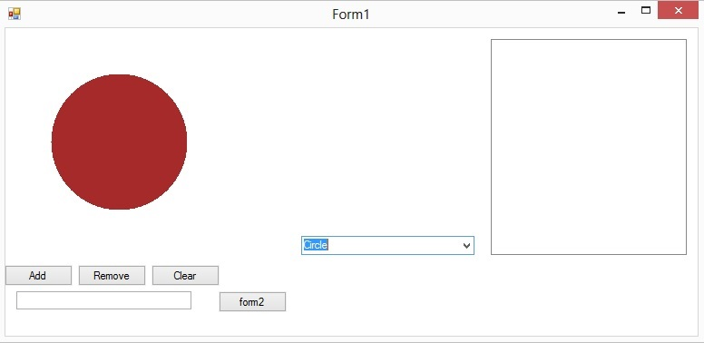

Timer Control:
he Timer Control plays an important role in the development of programs both Client side and Server side development. A Timer control raises an event at a given interval of time without using a secondary thread. If you need to execute some code after certain interval of time continuously, you can use a timer control.
Timer Class Properties
Enabled property of timer represents if the timer is running. We can set this property to true to start a timer and false to stop a timer.
Interval property represents time on in milliseconds, before the Tick event is raised relative to the last occurrence of the Tick event. One second equals to 1000 milliseconds. So if you want a timer event to be fired every 5 seconds, you need to set Interval property to 5000.
Timer t = new Timer();
Namespace: System.Timers
Assembly: System (in System.dll)

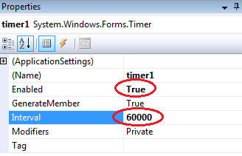

Task 2:
Create an array of Buttons that would display buttons dynamically at run time.
Sample Code:
private void Form1_Load(object sender, EventArgs e)
{
Button[] b = new Button[5];

for (int i = 1; i <= b.Length-1; i++)
{
b[i] = new Button();
b[i].Text = "Button" + i;
b[i].Size = new Size(70, 30);
b[i].Location = new Point(i + 70, i + 100);
b[i].Left = 50*i;
b[i].Top = i * 70;
b[i].Click += new System.EventHandler(button1_Click);
this.Controls.Add(b[i]);

}
}

Task 3:
Create a slideshow of pictures by using picture box control and timer control. Make a folder on any drive containing all of your pictures, you want to include in a slideshow. Rename all the pictures starting with 1.jpg, 2.jpg… n.jpg.

Task 4:
Using Mouse up, down and Mouse move events, Create an application that can draw freehand drawing.

Sample Code:
int readypaint = 1;

private void Form1_Load(object sender, EventArgs e)
{
timer1.Start();
}

private void Form1_MouseUp(object sender, MouseEventArgs e)
{
readypaint = 0;
}

private void Form1_MouseMove(object sender, MouseEventArgs e)
{
if (readypaint == 1)
{
Graphics g = CreateGraphics();
Pen p = new Pen(Color.Red);
g.DrawEllipse(p, e.X, e.Y, 10,10);
}
}

private void Form1_MouseDown(object sender, MouseEventArgs e)
{
readypaint = 1;
}

